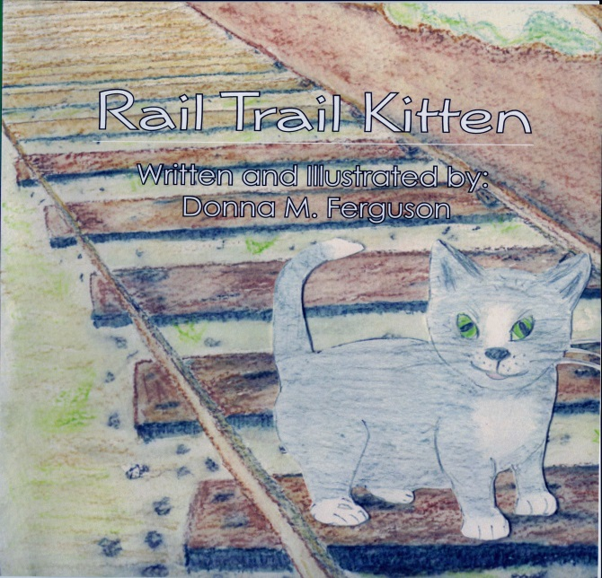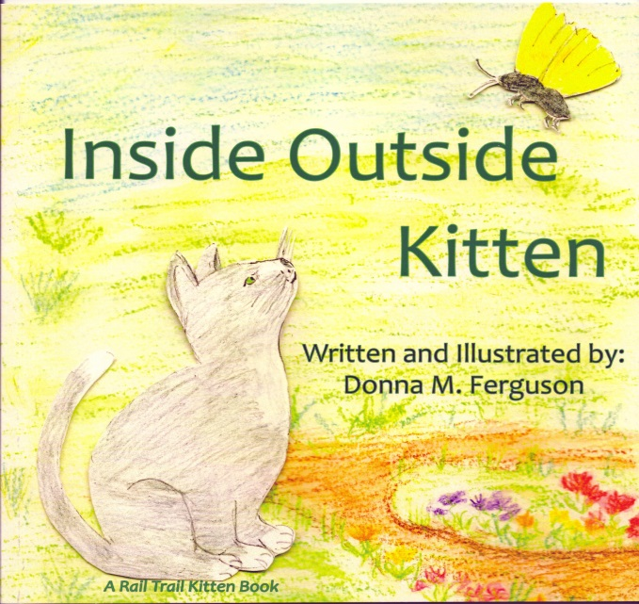
The homeless grey and white kitten on the Heritage Rail Trail inspired the

Rail Trail Kitten and Inside Outside Kitten books.
“Moo” Is Hard To Do is about a cat who thinks she is a cow who lives at Perrydell Farm and Dairy.
Tagalong Turtle has one goal-to reach the ocean. What adventures will she have on her journey? Discover loggerhead sea turtle facts included in the book.
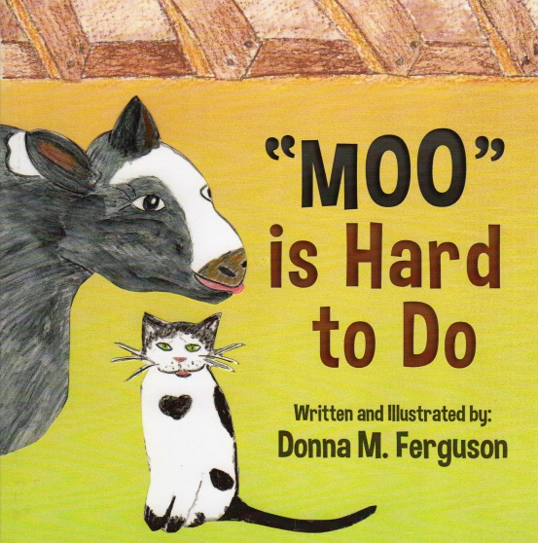
. 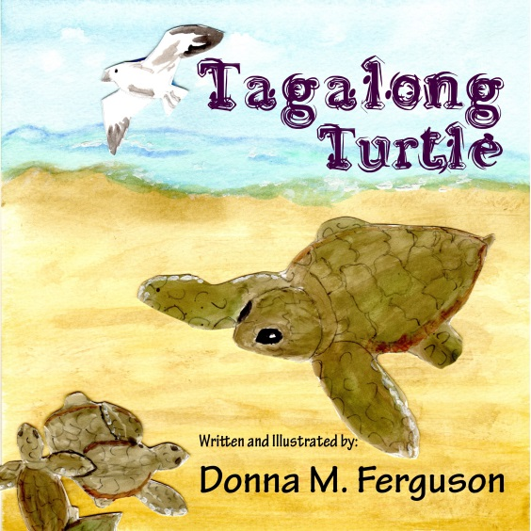
Each signed book is $10.00

