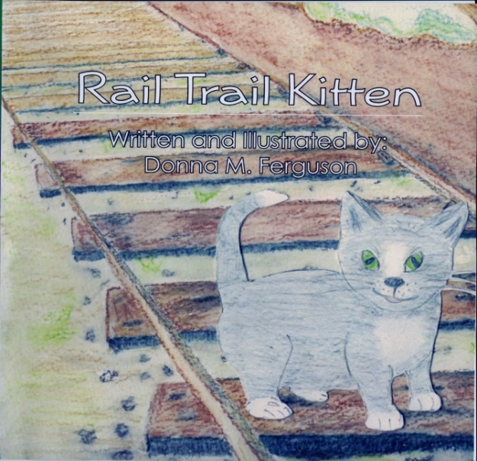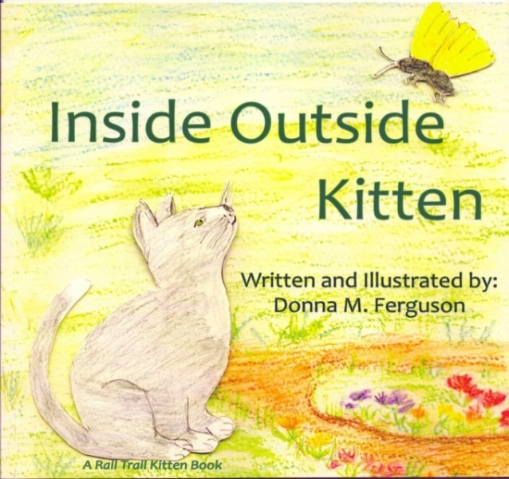
Rail Trail Kitten and Inside Outside Kitten
The homeless grey and white kitten on the Heritage Rail Trail inspired both books.

“Moo” Is Hard To Do is about a cat who thinks she is a cow who lives at Perrydell Farm and Dairy.
Tagalong Turtle has one goal-to reach the ocean. What adventures will she have on her journey? Discover loggerhead sea turtle facts included in the book.
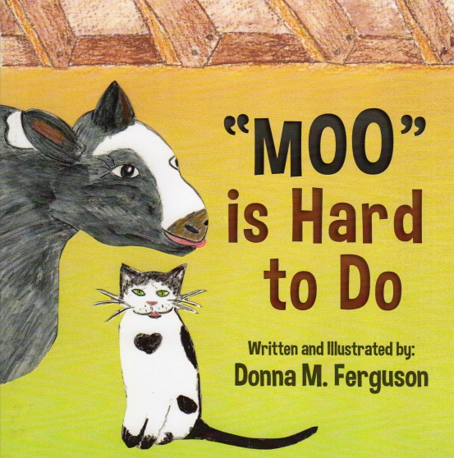
. 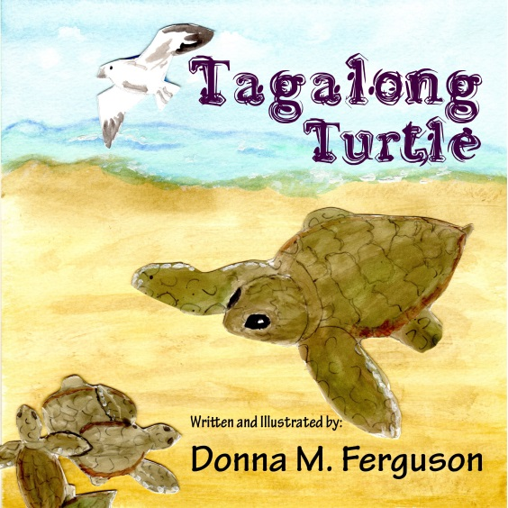
Each Signed Book $10.00
Includes PA Sales Tax

